

West Australian Test Papers

PHYSICS

Year 12

2007

SOLUTION BOOKLET

&

MARKING GUIDE

Markers should note that the solutions presented here are skeletal answers and
should be used as a guide only.

Alternate answers used by students may be perfectly acceptable and discretion
should be used.

Section A: Short Answers

1. Key idea is that a pulse is emitted and the time taken for the pulse to be reflected is
measured and the formula: distance = speed x time is used.
Distance calculated needs to be halved to find the depth

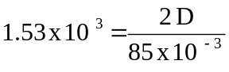 D = 65m

2.
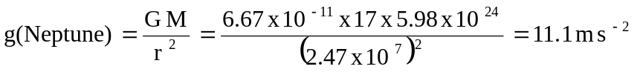

3. Key idea is that the vase B has the lower Centre of Gravity. Therefore B would require
a greater angle before its Centre of Gravity was over the pivot point and before it tipped
over.

4. (a) 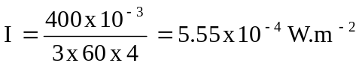

(b) Determine the sound intensity at this point.

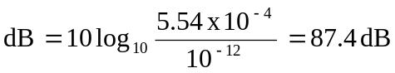

5. (a) F(max) = 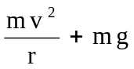 v = 30 m s ⁻ ¹
= 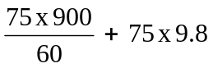
= 1125 + 735 = 1860 N

(b) At the bottom of the loop.

6. (a) Resolving vertically 0.8 = ½9.8 t² so t = 0.404 s

(b) Distance = 0.404 x 5 = 2.02 m

7. (a) 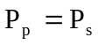 Increasing voltage means a decrease in current as 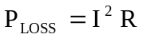.
This reduces losses. Safety: cannot have separation of active and neutral as large
as in the high voltage situation.
(b) Not needed: current through wire is reduced considerably as is its length
so line loss is not as significant.

8. Key idea is destructive interference, path difference LS1 to B and LS2 to B is integer
number of half wavelengths.

9. (a) Lenz’s law, the disc cuts the magnetic field from the permanent magnet
and has a current induced in it . This induced current flows in such a direction that
the field it produces opposes the existing field thus providing an opposing force
causing the car to slow down.

(b) The E _{K} of the car is converted to electrical energy in the disc. This is then converted
to heat in the disc.

10. (a)
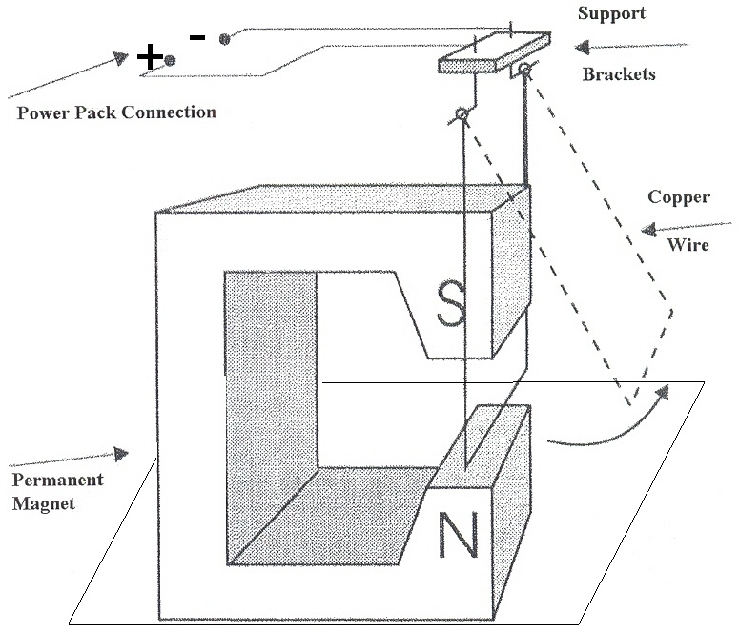

(b) The wire is carrying a current and therefore has its own magnetic field. This field
interacts with the permanent magnet’s field creating an equal and opposite force
on the magnet and the wire. The mass and friction of the magnet on the surface stops it
moving but the wire is free to move. The direction of the movement is described
by the appropriate hand rule.

11. Torque = n l b I B
=

12. (a) Clockwise circular path.

(b) 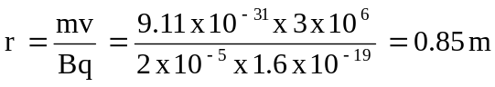

(c) anti clockwise, bigger radius.

13. (a) E = hf
Energy = 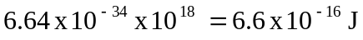 (Range 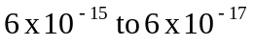)

(b) Number of photons = 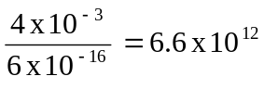 (allow range 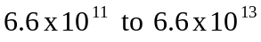)

14. (a) Ground state is E(-5.12) and the first excited state is E(-3.01) eV. (1 mark)

(b) ΔE = h x 525 x 10 ¹² = 3.5 x 10 ^{– 19} Joules = 2.17 eV.
Transition n = 1 ⇒ Ground state since ΔE = 2.11 eV.
(Actual frequency = 508 x 10 ¹² Hz.)

15. Equation (b) is correct.

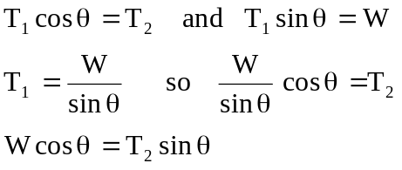

Section B

1. (a) Force up = Force down (resolve vertically)
170 + 250 = 40 x 9.8 + M
M= 28 N (3)

(b) Take moments about A,
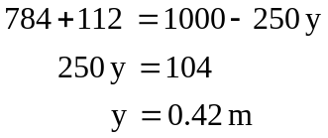 (4)

(c) Y.M. = 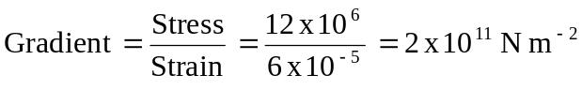 (2)

(d) 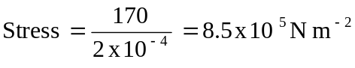 (2)
(e) Energy stored per m³ in the wire whilst under tension. (2)

2. (a)
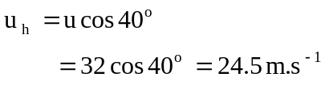 (2)

(b)
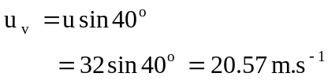 (2)

(c) Resolve vertically, (down +ve)
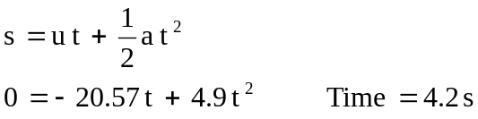 (3)

(d) s _{h} = 4.2 x 24.5 = 103 m (2)

(e) When s _{h} = 40 m then t is,

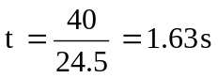
Now find s _{v} at time = 1.63s
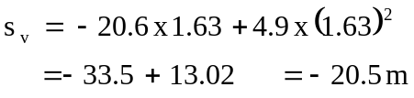
Yes, it will clear the tree. (4)

3. (a) Key idea is that you have variable frequency f_{v} and a fixed natural frequency
f_{o} and when these frequencies are the same ie f_{v} = f_{o} then resonance occurs.
It is an example of constructive interference between two waves travelling in
opposite directions 180⁰ out of phase in the same medium. (2)

(b) Amplitude increases and therefore a loud sound is heard. (2)

(c) Draw the displacement standing wave pattern for the fundamental. (2)
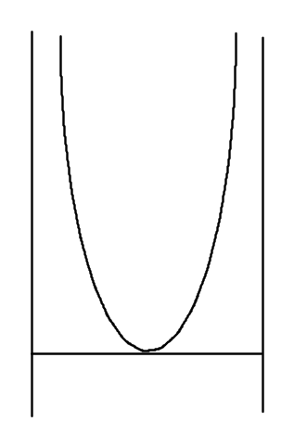

Frequency (Hz) | Length of tube (mm) | 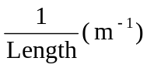
530 | 140 | 7.1
400 | 195 | 5.1
300 | 270 | 3.7
250 | 330 | 3.0
200 | 455 | 2.2
150 | 665 | 1.5
(d)
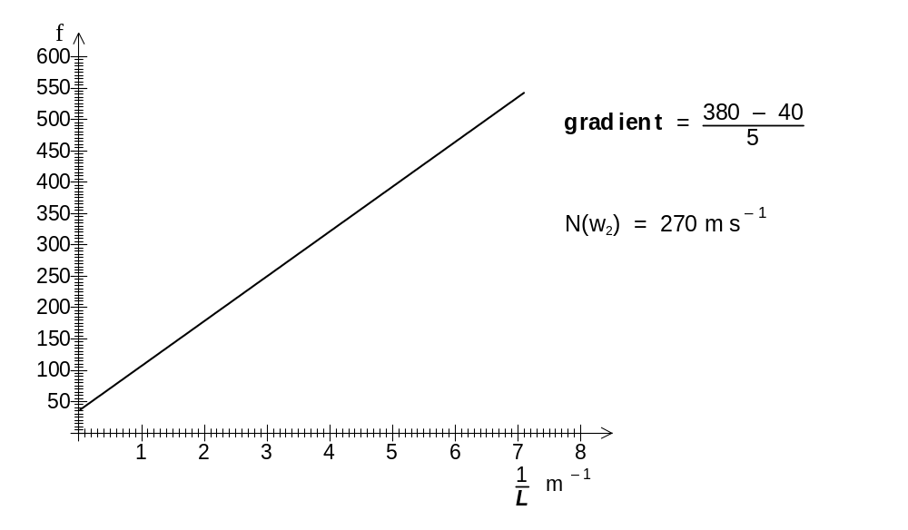
v = f λ
v = f 4 L where L is the length λ= 4L for the fundamental

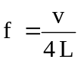 so if plot frequency against 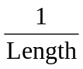 then gradient is 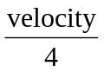

As y = mx

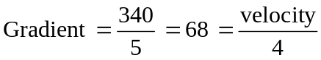
Velocity of sound in CO₂ = 277 ms⁻¹ (5)

(e) Students should demonstrate they understand the standing wave extends outside
the dimensions of the tube and an “end correction” should be included.
No details needed. (2)

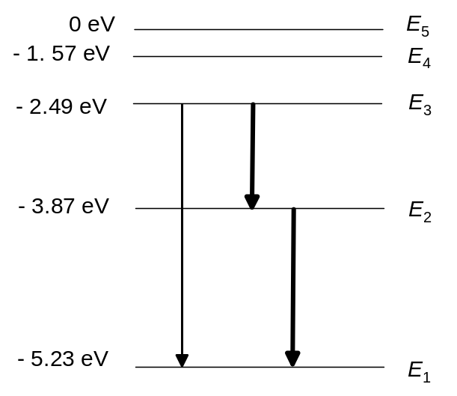4. (a)

(3)

(b) E₃-E₁ = h.f should identify this transition as the only one to consider
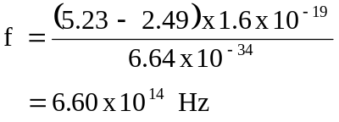 (3)

(c) Border of visible / infra red via data sheet (1)

(d)
key ideas
- Electrons are excited by thermal or collisions to a higher allowed energy level.
- Return to the ground state via a few possible decays all of which have an energy
associated with them.
- These allowed transitions have different energies, frequencies (and colours) and are
unique to the element / compound.
- Spectroscopy is a powerful tool in identification of unknown compounds since the
spectra are unique. (4)

5. (a)
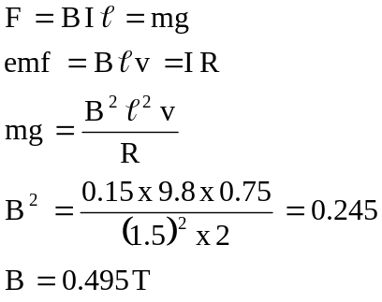 (5)

(b) Key idea that there is an induced current in the wire and this results in
magnetic force/ field which acts in such a direction as to make the rectangle
slow down. Eventually when this (Lenz Law) force is equal and opposite to the
weight it will continue at constant speed. (2)

(c) There will be no net induced current because the currents produced in the top &
bottom wire sections will be in opposite directions and equal in magnitude.(2)

(d) Time for 1 revolution = 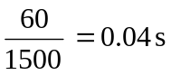
Time to go a quarter revolution = 0.01 s

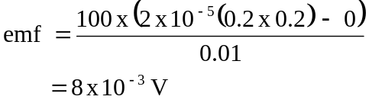 (5)
6.
(a)
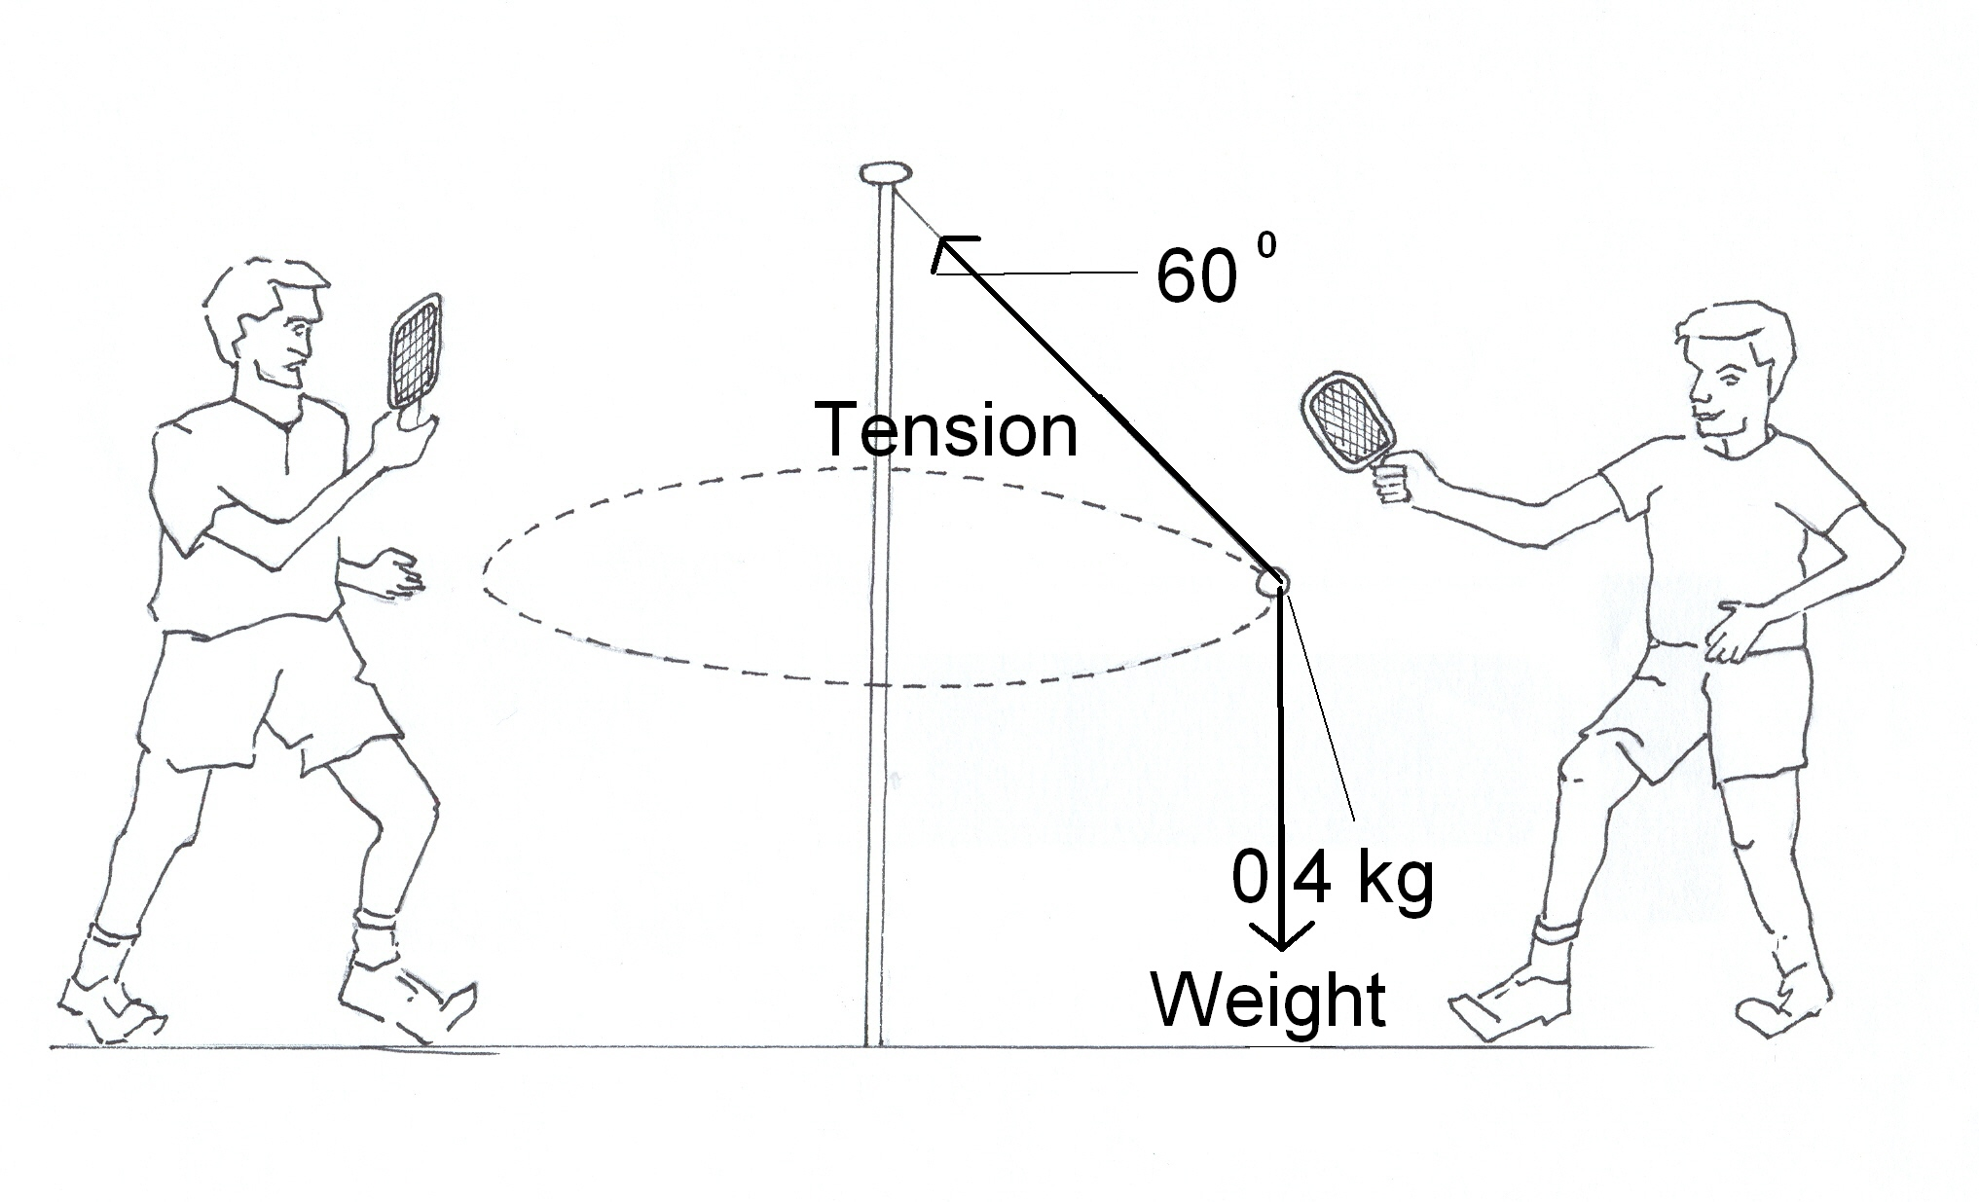 (2)

(b)
Resolve vertically
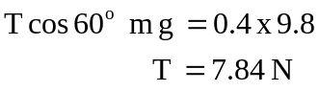 (3)

(c)
Resolve horizontally
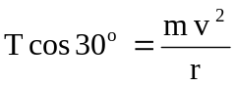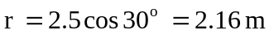
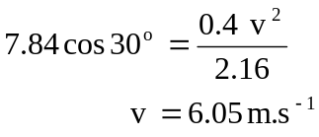 (4)
(d)
Speed decrease (1), give reason (2) (3)

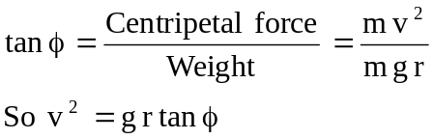
So as speed decreases then φ will decrease (r depends on tan φ proportionally)
7.
(a) Step down voltage transformer,
Change 110 kV to 240 V
 (3)

(b) Line losses reduce
As the voltage is increased then the current is reduced and the line loss I²R reduced
P = I²R (3)

(c) Total resistance = 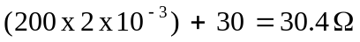
V = I x R
240 = I x 30.4 I = 7.89 A
At kettle V = 7.89 x 30 = 236.7 V
Power = I ² R = (7.89) ² x 30.0 = 1867W
or (4)
(d) Current demand will increase so the line loss along the 40 km line will increase
Therefore the output from transformer will be reduced and the power available to
the kettle is decreased. (3)

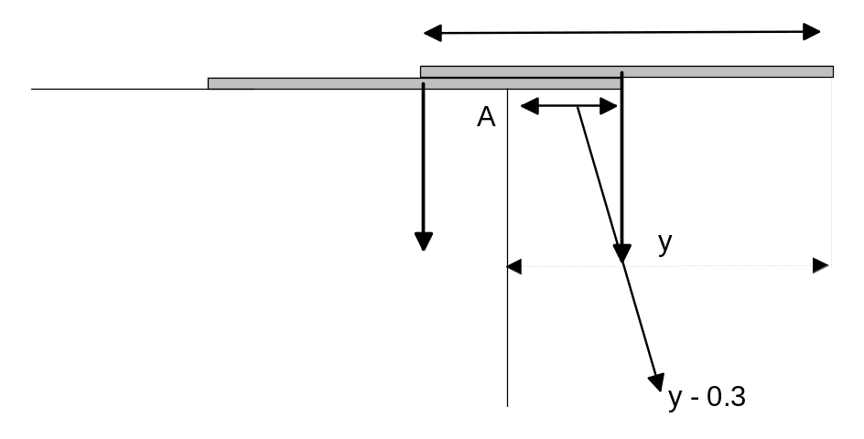8. (a)

Take moments about the table corner, A.
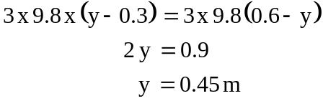 (4)
Or by symmetry
y = 0.45 m
(b)
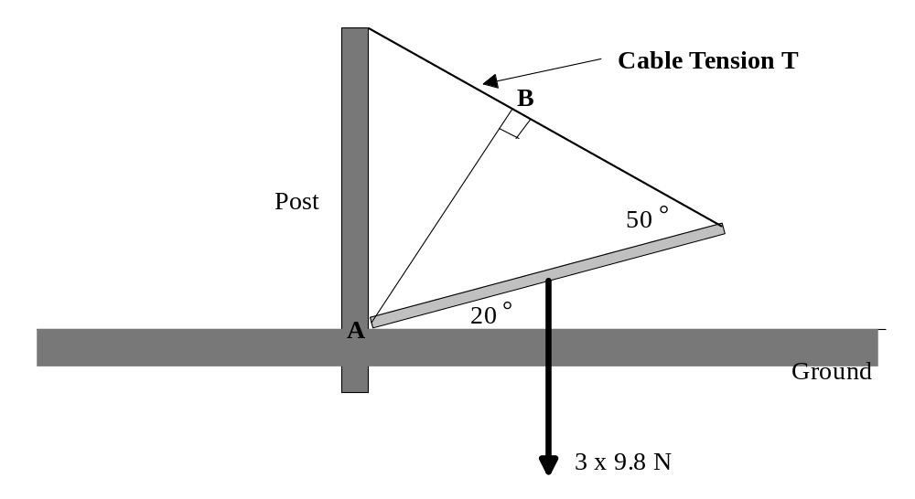

Take moments about A,
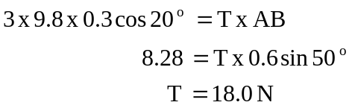 (4)

(c)

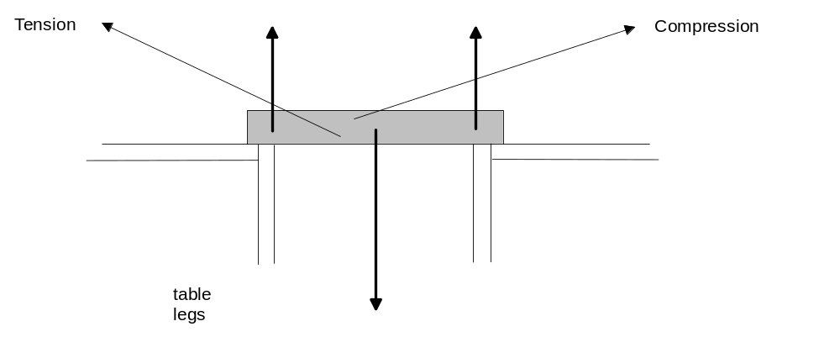

(4)

END OF SECTION B

Section C: Comprehension and Interpretation

Question 1.

1. In the future the computers will be more powerful, needing larger microprocessors that will use more power generating more heat and need bigger fans to keep them cool. (2)

2. As the fan moves more quickly it has more kinetic energy and this is passed on to the air particles in the neighbourhood causing them to vibrate with larger amplitude i.e. louder. As the fan rotates more quickly blades impact more frequently on the air molecules increasing the frequency of the sounds. (3)

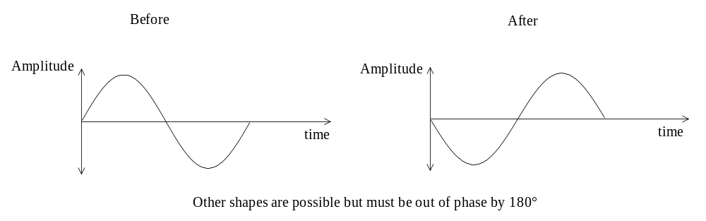3.

(3)

4.
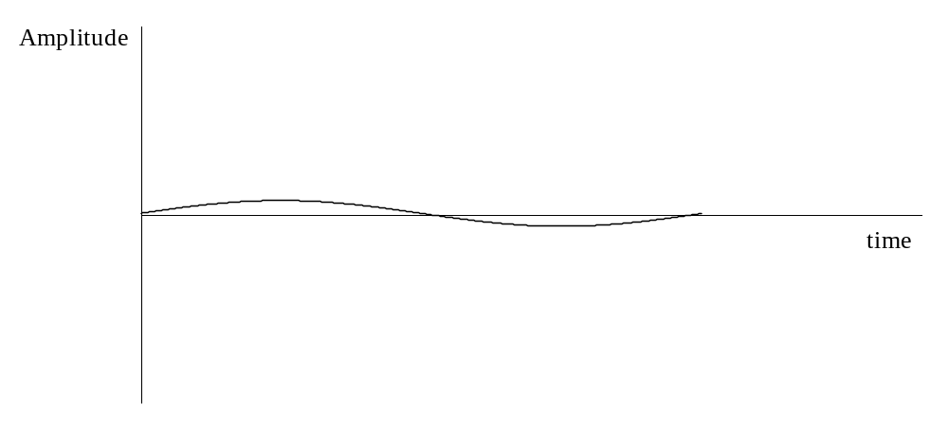

(3)
5. Destructive interference, the law of superposition causes a cancellation of the noise.
(2)
6.
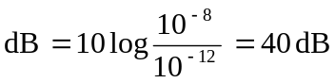
New level is 40 dB – 20 dB = 20 dB
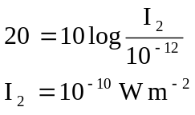 (3)

7. It has to do with the path difference varying with the distance between the parts of the fan and your head /ears. If this is always changing then by averaging the incoming sound a better noise reduction will be possible.

8. Yes after passing through the ANC the sound is quieter. (1)

9. It could be used to reduce unsafe and/or annoying noise. Thus providing a safer and more
pleasant environment. Any suitable example (1). The reason stated above (1) e.g. a noisy drill
reduced the need for the user to wear ear muffs.

Question 2.

1. Either, those between the earth and the sun or Mercury and Venus only. (2)

2.
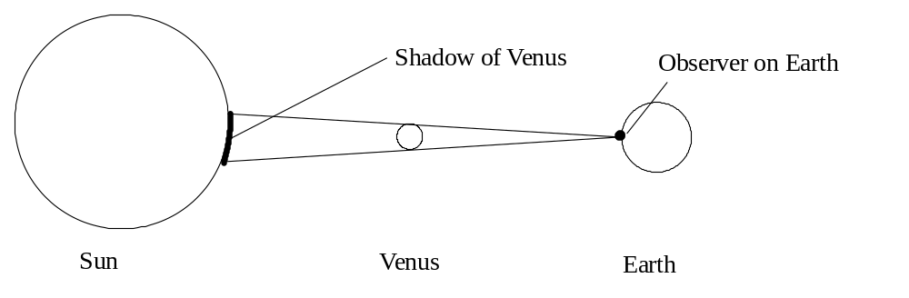

(3)

3. The orbital planes are inclined to each other therefore Venus, the Earth and the Sun are rarely lined up. (3)

4.
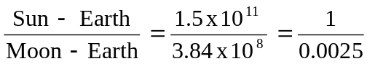
 (2)
5.
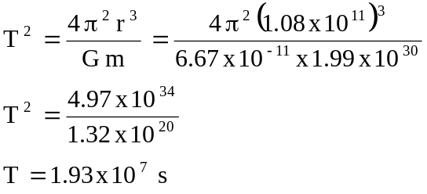 (3)

6.
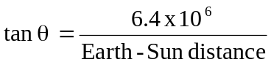
Earth – Sun distance = 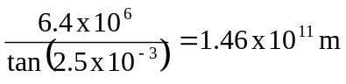 (3)
7. So the triangle used to calculate θ is as large as possible so the error is minimised.
(2)
8. So as not to confuse the sunspots with the planet Venus. The sun’s rays will damage
your eye if you view directly. (2)

